Design
App Layout
This app can be broken down into a few key components. I will develop these sections to work individually then combine them together to make the app. These components are as follows:

- Home:
  - This screen will be the landing tab the user will see when they open the app.
    - This screen will contain most recent listened to songs, favourites, playlists, etc.
    - Play menu will be at bottom with song/playlist in same position as when app was closed.
    - Button to scan for audio files and settings button will be at top along with a search bar to search for songs.
    - Tabs for other menus such as music finder, playlists, tracks, favourites
- Settings:
  - This screen will be where the user can change various options in the app.
    - Will be split into various sections each relating to different sections of the app (Apperance, downloads).
- Playlists:
  - This screen will be where users can see their playlists.
    - Contains button to create a new playlist at the top.
    - Shows all playlists in alphabetical order along with runtime and number of songs.
    - Clicking on a playlist brings up all the songs in said playlist, each stating its name and duration.
    - Holding and dragging a song will rearrange its position in the playlist.
    - Buttons to play/shuffle playlist or add/remove songs at the top.
- Tracks:
  - This screen will be where users can see their downloaded tracks
    - Acts similar to Playlists screen but will show all tracks downloaded rather than separating into smaller custom playlists

- Music Finder:
  - This will be further broken down into search and download.
  - Search:
    - User inputs a search query in search bar at the top of the screen.
    - Program then brings up a list of up to 25 relevant search results.
    - Search bar will still be at the top of the screen in case user wants to search something else.
    - If no results found or unable to perform search then an error message will be displayed.
  - Download:
    - On the search result there will be a button user presses to trigger a download. Download will start in the background. Progress can be seen in downloads tab. Once downloaded, relevant file info will be uploaded to SQLite database.

- Player:
  - This screen will be where users can control the player.
    - It will show the progress through the song, song name and player control options like shuffle, loop, play/pause, skip song/go back song.
    - Button which the brings up player song queue.

- Favourites:
  - This screen will be where users can see their favourited tracks
    - Acts similar to Tracks screen but will show all downloaded tracks which have been favourited rather than just showing every track downloaded.

App Visualisation
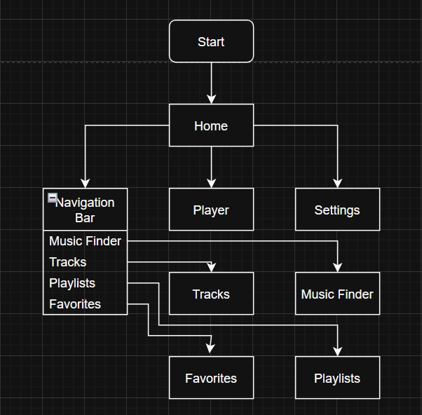
This flowchart demonstrates how the structure of the app will work. The app will open up to the home page giving the user direct access to the player, the settings and the navigation bar.

From there, a large majority of the time the user can just click on the player’s play icon at the bottom of the screen and start playing their playlist. If they need to access something else they will be able to normally find it on the navigation bar.
At anytime the user will be able to quickly navigate back to the home menu through the navigation bar as all the links are 2 way.

Home
This page will be the screen they see when they open the app.
FILL IN AFTER

Music Finder
This portion of the app will search for and allow users to search for and download music from within the app. This section can be broken down into 2 sections which happen one after the other. The search portion and the download portion.

Search:
The search mostly only just sends requests to YouTube to tell it what to display as the catalogue of available songs to download is any videos available to watch on YouTube. It will run whenever the user attempts to search for a song to download.
It has 2 modes a direct search which bypasses the entire search and gets directly sent to the downloading portion of the program. This is more useful for downloading playlists or unlisted videos which won’t show up on the regular search.
The other mode is keyword which is the default and how a user would normally search for something as they would not have the URL memorised.
Once a query is sent from the user it is put into an API request to YouTube which will then return a list of the top 25 results from the search in a JSON format. This response is then cleaned for anything that is not a video such as channel pages and channel posts as these are unnecessary to the user.
The cleaned response is then parsed through with each item then being displayed nicely by the program. The user can then click on a song to start downloading it.

Below is a flow chart showing how the process will roughly work.
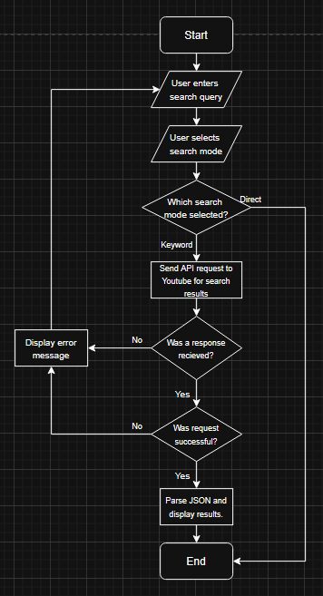

Below is the pseudocode showing what the program will be doing when searching for a song

Search Algorithm Pseudocode:
def search(search_mode, search_query):
# Both gathered out of function from buttons / text box

# Checking if user wanted to directly download
if search_mode == “direct”:
download(search_query)
display(“Download started. Check downloads.”)

# User did not want to directly download therefore searching.
# First we are sending a query to YouTube to get a search result
try:
response = send_query(search_query)
except Error as err:
# Response failed to send. Error message is to be displayed.
display(err)

# If except block not triggered then response successfully sent.
# Checking if YouTube declined request
if response == “bad Request 400”:
# Youtube Declined Request but did receive it. Reason displayed
display(response)

# Response successful so we clean out any unnecessary values.
results = clean_response(response)

# Cleaned response then displayed nicely.
display(results)

Variable explanation
Variable Name | Type | Description | Justification

Download:
This part of the program activates once the user clicks on a song to download it. Once the user clicks on the song, first the program gets the video code if the user is finding a song via keyword search or it directly takes the URL if using direct search. Then, it calls a function which will get the users configuration settings for downloading songs from a SQLite database and put it all into a dictionary. Then the yt-dlp module’s download function will be called to download the requested songs. If any errors occur they will
The songs will be downloaded to a temporary folder to prevent partially completed downloads from cluttering the target download folder. Once the download is completed the metadata such as artist, track length, song name, etc will be read from the file and put into a SQLite database so database creation is easier afterwards the downloaded file is sent to the folder specified in the user’s config. If the folder does not exist the file will remain in the temp folder and an error message will be thrown to notify the user that the download was successful but the file remains in the temp folder and that they should move it themselves.
Below is a flowchart showcasing how the algorithm will work.
